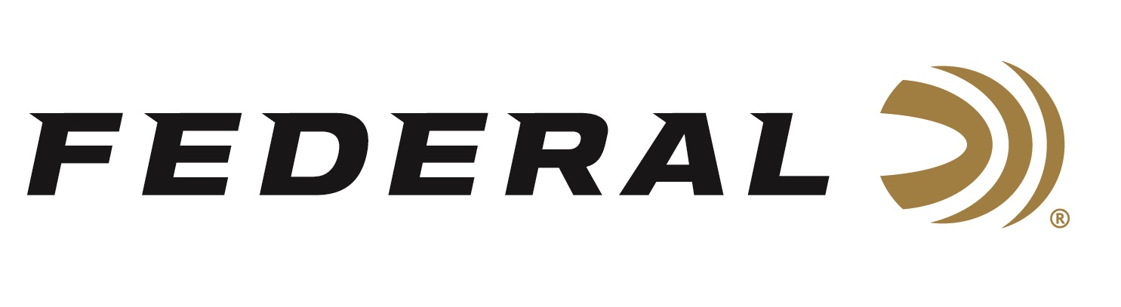

FOR IMMEDIATE RELEASE

Federal Ammunition Sponsored Shooters Earn Coveted Spots on U.S. National Teams

ANOKA, Minnesota – December 5, 2025 – Four-time Olympic Gold Medalist Vincent Hancock leads the list of Federal Ammunition-sponsored shooters who recently earned their way onto U.S. National Shotgun Teams for future events. Spots on the Men’s and Women’s Trap and Skeet and Junior teams were on the line at the Fall Shotgun Selection Match held at the Tucson Trap and Skeet club in Tucson, Arizona. The selection competitions for Skeet began on November 18, and the event concluded with the finals for Trap on November 22, 2025.

Vincent Hancock was the overall winner in the Men’s Skeet match. Hancock led the field of finalists by four targets and claimed the top podium spot by winning the final outright. Hancock’s Paris teammate and Olympic Silver Medalist, Conner Prince, also qualified for the National Team.

“Federal Ammunition is extremely proud of the performance turned in by Hancock and at the Fall Selection Matches,” said Jason Nash, Federal’s V.P. of Marketing. “Vincent is the gold standard when it comes to competing on the world stage in Men’s Skeet and we are excited to witness the continued growth of Conner as he builds on his resume and success from the Paris Olympics.”

In the Trap portion of the Fall Selection Match, Federal’s Derrick Mein and Kayle Browning earned their way onto their respective National Teams. For Mein, it is his second Team USA affiliation having already qualified for the Sporting Clays team representing America. Browning was a Silver Medalist at the 2020 Tokyo Olympics.

Federal is the number one choice for shotgun shells and manufactures products in America for all competitive and recreational disciplines. See the full lineup, including the latest Master Class and All-American target loads, at www.federalpremium.com.

Federal Ammunition products are available at dealers nationwide and online. For more information on all Federal products and to sign up for notifications about new product availability, rebate promotions, and other brand news via email, visit www.federalpremium.com.

Press Release Contact: JJ Reich
Senior Manager – Press Relations
E-mail: media@tkghunt.com

About Federal Ammunition
Federal, headquartered in Anoka, MN, is an ammunition brand of The Kinetic Group, owned by CSG, a globally diversified industrial group based in Prague, Czech Republic. Since 1922, Federal has been a leader in ammunition innovation, delivering high-quality sporting and hunting products to shooters worldwide. With a commitment to conservation and the outdoor community, Federal continues to manufacture industry-leading ammunition that enhances the shooting experience while supporting outdoor traditions.

